Step-by-step instructions for adapting our ePortfolio Feedback Generic Template

1. Copy this URL: https://www.jotform.com//?formID=61407555580154

2. Login to your account and go to My Forms

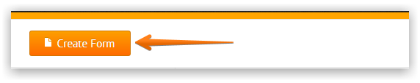
3. Click in Create Form

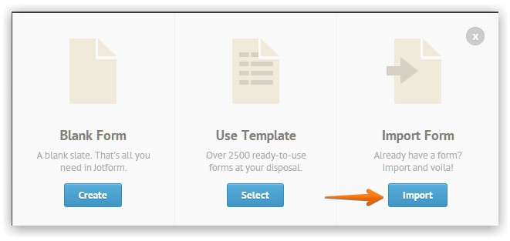
4. Click on Import Form

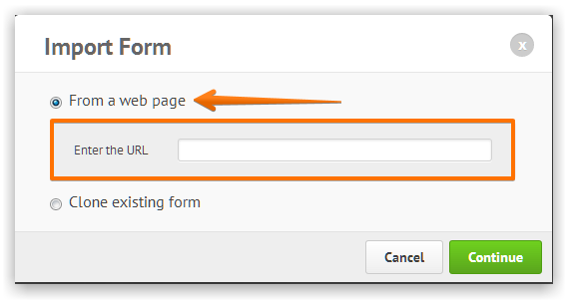
5. Click on From a Web Page and paste the form URL

6. Click on Continue button and your form should be cloned.

7. You can change the name of the survey by clicking on the title and typing.

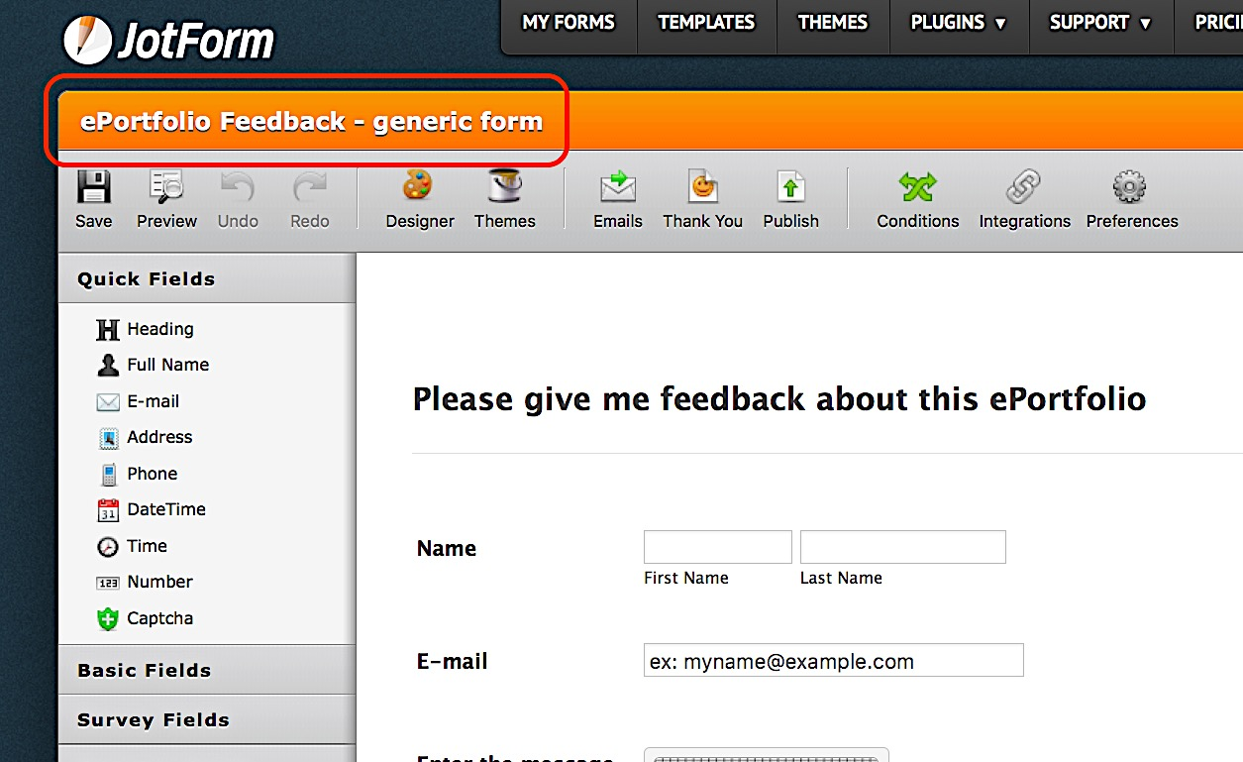

8. To change the colored bar header text, just click and start typing.

9. There are two ways to change the text in the cells. The first is to click on the row of cells you want to edit. Next access the Columns icon in the top bar and insert your own text, clicking OK when you are done. JotForm creates a cell every time you hit return so what you see below is three lines of text.
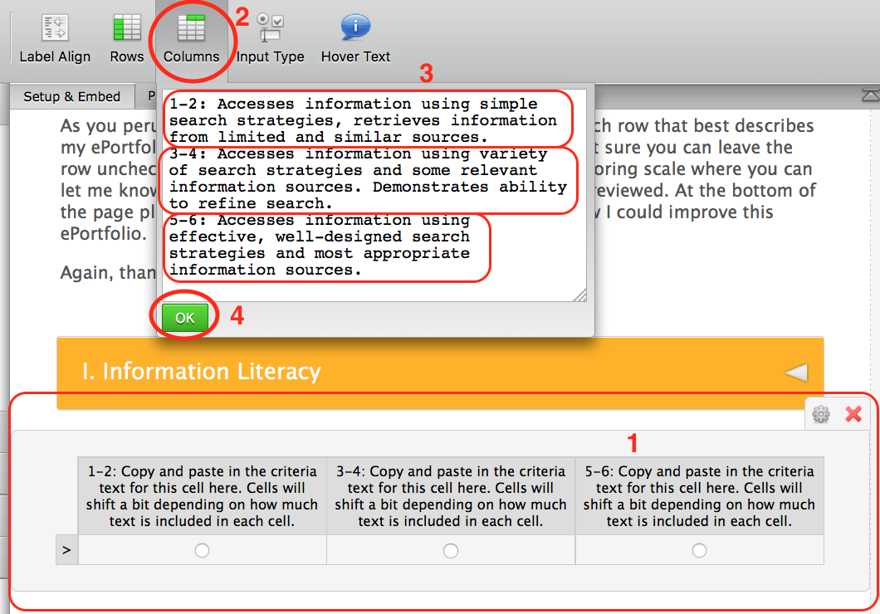

10. The second way to edit the rows is to click on the Gear Icon to access the drop down menu. From here you can Duplicate a row, Delete a row or Edit Properties.
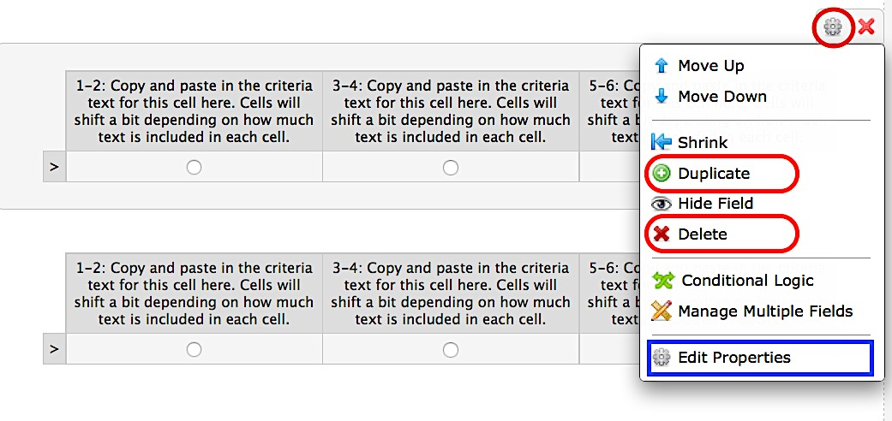

11. In the Edit Properties window you can also edit the text in the cells.
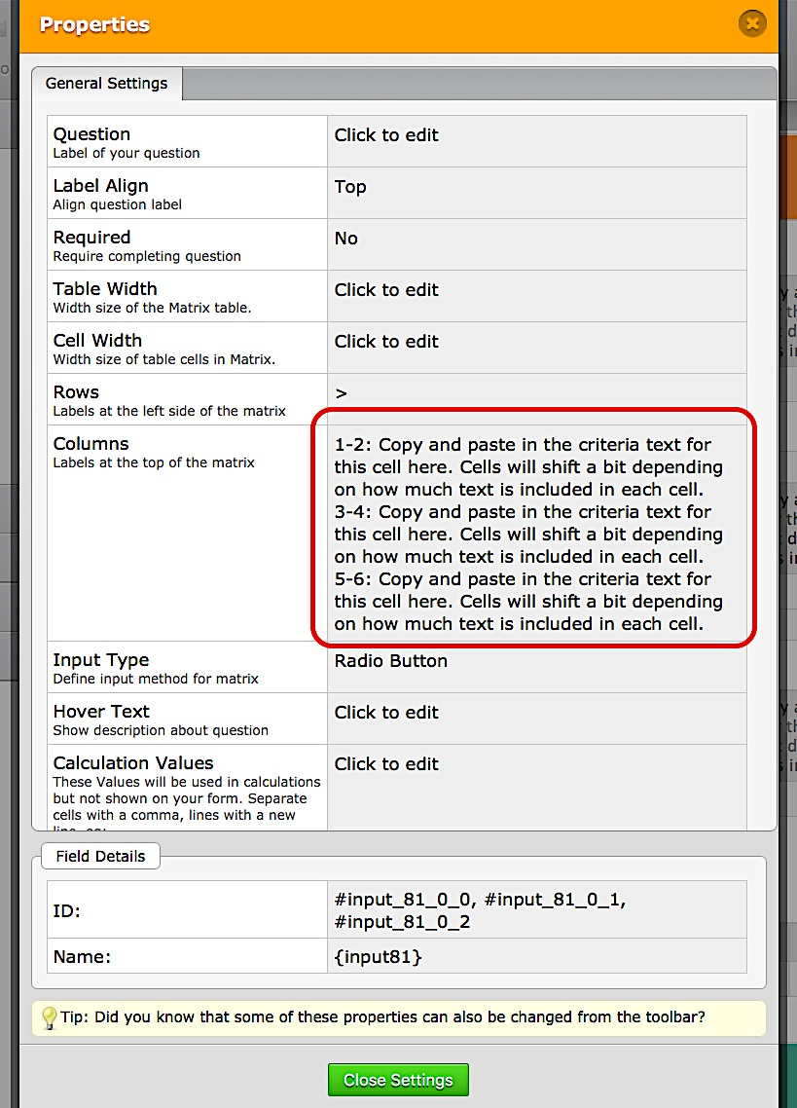

12. You can reposition any elements in the survey by dragging and dropping. And you can easily delete items by clicking on the red X.

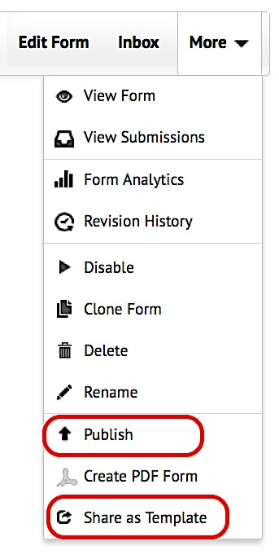
13. When you have finished your form you can publish it and embed it in a site by clicking on Publish. (More instructions in Step 9.) Go to you’re My Forms list and click on the name of your form. This will make the More link appear. Pull down the More dropdown menu and choose Publish. This is also the place where you can share your new form as a template by clicking on the Share as Template link and following instructions.

14. To embed a pop-up form on your site, choose Embed when the Publish window opens. Then choose Pop-up from the Embed drop down menu. Copy and paste the code into your site.
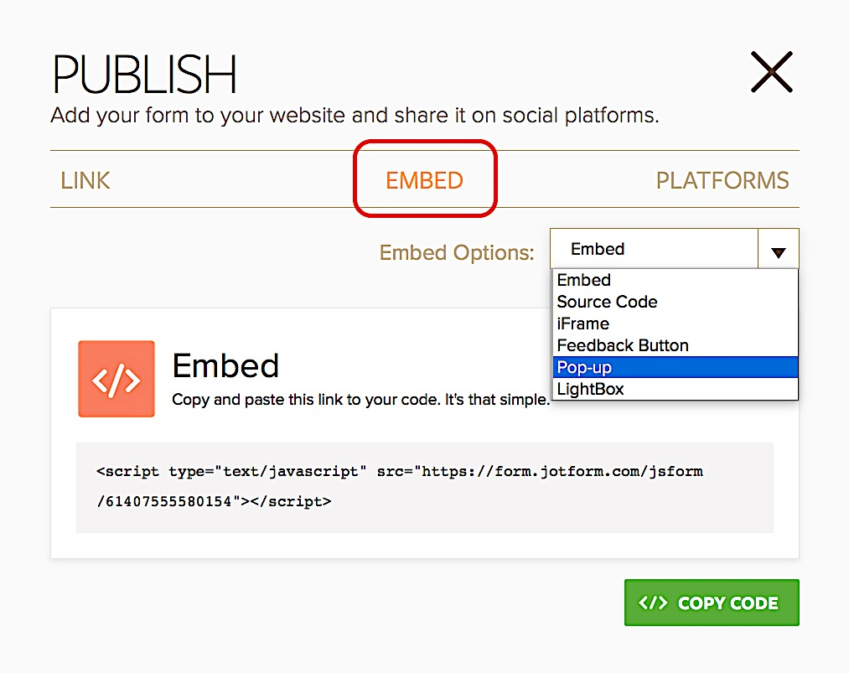

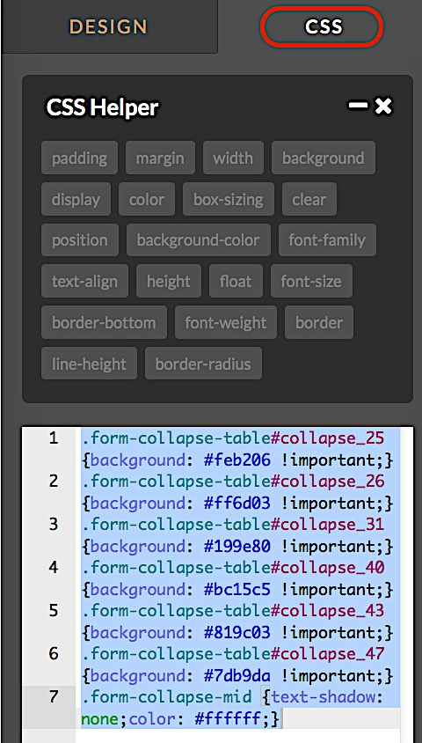
(P.S. If you want to change the colors of the collapsible headers you will need to do that in CSS in the Designer area. After clicking the Designer icon, click on the CSS tab and insert your own hex codes.)

